**Heart Disease Detection and Patient’s Sickness Prediction System**

Sakshi Singh, Chaitanya Pandey, Tanmay Patil, Gurjeet Singh

*(Dept. of Comp. Sci & Engineering,* *MIT-ADT University, India)*

***Abstract : -*** ***The Heart Disease Detection and Patient’s Sickness Prediction, is a crucial topic given the increasing incidence of heart diseases. Early detection of such diseases is of utmost importance and requires precise and efficient diagnosis. The project focuses on predicting the likelihood of a patient having a heart disease based on their medical history and various medical attributes, using machine learning algorithms such as logistic regression. The proposed model demonstrated strong predictive capabilities and outperformed previous classifiers such as Naive Bayes.***

***The Disease Prediction system, which is based on predictive modeling, utilizes the symptoms provided by the user as input to predict the probability of the disease using the Random Forest Classifier. The project aims to use various supervised machine learning algorithms in disease prediction and heart disease detection through symptoms and medical details as input, demonstrating the potential for these algorithms to aid in the early detection of high risk diseases.***

***Keywords :*** *Machine Learning , Random Forest, Logistic Regression, Data Preprocessing, Model Evaluation, Streamlit*

1. **Introduction**

Due to the substantial amounts of data, medical doctors are facing challenges to analyze symptoms accurately and identify diseases at an early stage. However, Supervised ML algorithms have showcased significant potential in surpassing standard systems for disease diagnosis and aiding medical experts in the early detection of high-risk diseases.

1. **Existing Work**

Much research and development efforts have been made to develop disease detection and prediction models. Commonly used supervised machine learning algorithms include Naive Bayes (NB), Decision Trees (DT), and K-Nearest Neighbors (KNN). According to the study results, Support Vector Machine (SVM) is suitable for detecting kidney disease and Parkinson’s disease, while Logistic Regression (LR) is highly effective in predicting heart disease. In addition, Random Forest (RF) and Convolutional Neural Networks (CNN) successfully predicted breast and common diseases, respectively. Despite advances in computing, doctors still need technology for a variety of purposes, such as surgical imaging and X-ray imaging. However, technology has yet to keep up with doctors’ levels of knowledge and experience. This is because many different factors, such as medical records, weather conditions, air, blood pressure, and others, must be considered in order to understand the entire process of labor. Medical decision support systems can help address this challenge by helping doctors make the right decisions. We used machine learning to analyze the hospital’s comprehensive data, allowing us to build models that can quickly analyze data and deliver results faster. By leveraging machine learning, physicians can make critical decisions regarding their patient’s diagnosis and treatment options, thereby improving patient care services. . The healthcare industry is a great example of how machine learning is revolutionizing the medical field.

To begin with, the ML algorithms used by most systems tend to have lower accuracy when compared to the ones we have used. Decision Tree Classifier and KNN are commonly used in existing systems, but they do not offer the same level of accuracy as our algorithms. Another reason for this difference in accuracy is the use of complex deep learning algorithms, which require a large amount of data to predict a disease, such as medical images taken from different angles, which in turn require medical expertise and other medical diagnosis details.

1. **Motivation**

Identifying and predicting diseases is critical to preventing their severity and fatal consequences. In India, the majority of deaths are due to heart attacks, especially among elderly people affected by cardiovascular diseases. To solve this problem, our prediction system uses various machine learning algorithms to predict the risk level of these diseases. The advent of artificial intelligence (AI) has enabled computer systems to act intelligently, like humans, by perceiving, thinking, and making decisions. AI encompasses multidisciplinary areas such as machine learning, computer vision, deep learning, and natural language processing. By applying optimization, statistical, and probabilistic techniques to past data, ML algorithms can learn and assist healthcare professionals in decision making, contributing to treat the patient appropriately.

1. **Objectives**
2. Goal is to use supervised ML algorithms to improve healthcare through accuracy and early detection of diseases that become harmful at a later stage.
3. ML models will be used to predict diseases ranging from common to severe, just to name a few that are located in the heart, kidney, breast and brain.
4. For sickness prediction, we used Random Forest Classification and logistic regression to detect heart disease.
5. **Project Plan**

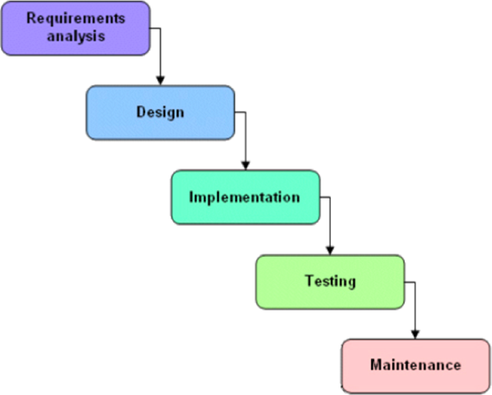

We used the waterfall method to develop the system. This picture shows a plan that we can use to get what we need. The Annexure includes some guesses or calculations. We thought about the stages in a waterfall model when making calculations. First, we looked at each part individually and then we calculated the necessary guesses.

1. **Methodology**

**Heart Disease Prediction**

The methodology for heart disease prediction using machine learning typically involves the following steps:

1. Data collection: Collecting the relevant data for heart disease prediction, which could include medical history, patient attributes such as age, gender, etc., and any other relevant information.
2. Data preprocessing: Cleaning and processing the collected data, dealing with missing values, and normalizing the data to make it suitable for use with machine learning algorithms.
3. Feature selection: Selecting the most relevant features that are likely to contribute to the accurate prediction of heart disease.
4. Model training: Training a machine learning model on the preprocessed and feature-selected data. The model is typically trained on a portion of the data, known as the training set.
5. Model evaluation: Evaluating the trained model using various performance metrics such as accuracy, precision, recall, and F1-score, among others. The model is evaluated on another portion of the data, known as the test set.
6. Model optimization: Tuning the model’s hyperparameters and optimizing the performance of the model by selecting the best combination of parameters and features.
7. Deployment: Deploying the trained and optimized model in the clinical setting to assist doctors and medical professionals in the accurate prediction of heart disease in patients.

**Heart Disease Dataset**

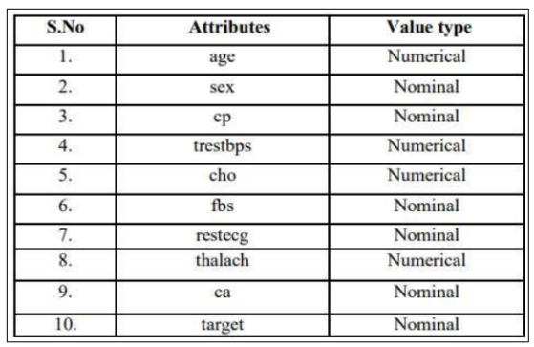

Logistic Regression is a Machine Learning Algorithm that predicts the output of a categorical dependent variable. Therefore the outcome must be a categorical or discrete value. It can be either Yes or No, 0 or 1, True or False, etc. but instead of giving the exact value as 0 and 1, it gives the probabilistic values which lie between 0 and 1. Logistic Regression is much similar to Linear Regression except that how they are used. Linear Regression is used for solving Regression problems, whereas Logistic regression is used for solving the classification problems.Logistic regression involves the following data and operations:[1]

1. Gather columns
2. Splitting Data
3. Normalization
4. Fitting into Model
5. Prediction
6. Model Evaluation

**Patient’s Sickness Prediction**

An Excel sheet was created from an open-source dataset, listing all the symptoms for respective diseases.The dataset contained approximately 230 diseases with over 1000 unique symptoms. The symptoms of an individual were used as inputs for various machine learning algorithms.

**Random Forest Classifier**

Random forest, as its name implies, consists of a large number of individual decision trees that operate as an ensemble. Each individual tree in the random forest spits out a class prediction and the class with the most votes becomes our model’ prediction.[2]

**Patient’s Sickness Dataset**

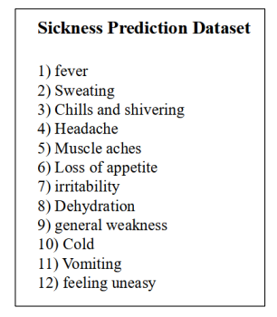

**Working**

1. The website will collect input data from users and utilize a training dataset to determine the outcome.
2. When the user clicks the result button, it will trigger a request to the Streamlit server containing their inputs, which the server will subsequently restructure.
3. Subsequently, the inputs will be fed into a trained model.
4. The model will analyze the provided data and generate a forecasted output.
5. The server will transmit the forecasted output to the web application as a response, and the web application will exhibit the projected outcome

1. **Usage Scneario**

**Heart disease Prediction**

Early Detection: It can predict the likelihood of heart disease in a patient before the disease becomes severe. This can help in early detection and timely intervention to prevent or manage the disease.

Risk Assessment: Healthcare providers can use model to assess the risk of developing heart disease in patients based on their medical history, lifestyle factors, and other risk factors. This can help in developing personalized treatment plans and preventive strategies.

**Patient’s Sickness Prediction**

Suppose a provider wants to predict the likelihood of a patient being diagnosed with a certain disease based on their current symptoms. The provider collects patient’s current symptoms.[3].

It can be used to predict the likelihood of a patient being diagnosed with a certain disease based on their current symptoms. This information can be used by healthcare professionals to identify high-risk patients and provide early interventions or treatment plans. Additionally, the model can be continuously updated with new data to improve its accuracy over time.

1. **Use Case**

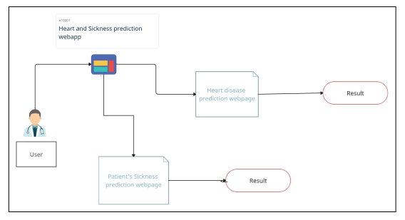

1. **System Architecture**

A system with an i5 quad-core processor, 6 GB of RAM, and software packages such as pandas, python, SciPy, StatsModels, and Matplotlib is required. Test analysis was performed in the Jupyter and Spyder web application environments. The analysis is done at two levels: first, the dataset is cleaned using Pandas tool, and second, the cleaned data is passed through classifiers to predict heart disease.

• Python: It is utilized as the back-end programming language to implement the prediction models.

• Streamlit: It is an open-source Python library used for building interactive web applications for data science and machine learning projects. It simplifies the process of creating a web application by allowing developers to create a user interface with simple Python scripts. We have used this for the frontend development

• Jupyter Notebook: It is often used in data science and machine learning projects for data exploration, analysis, visualization and for training and testing data and for creating models.[4]

• Spyder: It is an open-source integrated development environment (IDE) for scientific computing in Python. It provides a powerful editor for writing code, a console for executing code, and tools for debugging and profiling code.

• Libraries : NumPy to deal with huge data-set in numerical form, Pandas to analyze the data, Pickle for creating model.sav files, Stream-lit and streamlitoptionmenu for creating website, Sklearn for traintestsplit , logistics regression for accuracy and Sklearn for random forest classifier

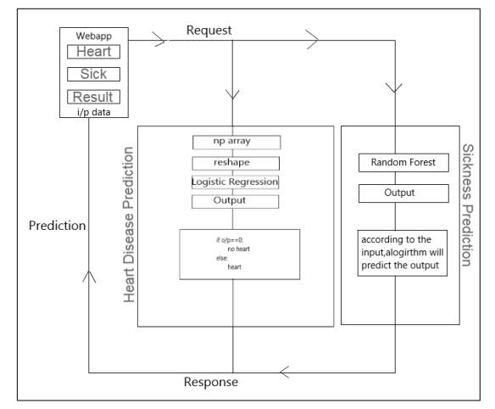

1. **Project Scope**

The incidence of heart disease is steadily increasing around the world, including in our country. To address this, we used logistic regression to detect and predict heart disease, achieving 81 accuracy. Although this accuracy is satisfactory, it can still be improved by exploring alternative methods for attribute selection and increasing the size of the dataset to avoid overfitting and improve performance. Alternatively, we may consider leveraging the power of deep learning algorithms to achieve even more accurate results in the future.

1. **Future Work**

The project aids in disease prediction at both personal and public levels. It provides information about the potential risk factors, thus reducing the need for unnecessary tests and associated costs. Moreover, the system can extract and analyze data from patients to reveal hidden patterns, which can be useful for future research and medical advancements.

During the training and testing phase of our project, we evaluated multiple machine learning models for predicting common diseases. The Random Forest Classifier model emerged as the most effective and accurate model with a precision of 95 percent. For the prediction and detection of heart disease, we utilized Logistic Regression which yielded an accuracy of 81 percent. There are various possibilities to further improve the accuracy of this model in the future. The Heart disease detection model using Logistic Regression and the sickness prediction model using Random Forest Classifier showed superior results. These algorithms are not only more accurate but also cost-efficient and faster compared to the algorithms used by previous researchers. The Random Forest Classifier achieved a maximum accuracy of 95 percent, and Logistic Regression accuracy was 81 percent, which is either greater or almost equal to the accuracies obtained from previous research. We can conclude that our accuracy has improved by using additional medical attributes from the dataset we used and can also improve more in future updates.

There are several ways in which we can further enhance the accuracy of our system. For instance, we can explore the utilization of deep learning algorithms,[5] consider alternative techniques for attribute selection, and potentially expand the size of the dataset in the future to address issues related to overfitting and to improve overall performance.

1. **Conclusion**

We worked as a team, and gained some experience on how professional programmers work in the industry. There is always room for improvement, and this application we created can also be improved. This is especially because we had to create it within a limited time due to other projects, quizzes and Exams. The main goal of our system is to help detect any illness a person may be carrying early, allowing doctors to keep the treatment on track. This is especially helpful for people with heart problems because they can determine if they are at risk for heart disease. By using our system, individuals can benefit from early detection and treatment, which ultimately leads to better health outcomes.

**Acknowledgements**

It gives us great pleasure in presenting the project report on ‘Heart Disease Detection and Patient’s Sickness Prediction System’. We would like to take this opportunity to thank my internal guide Prof. Shahin Shoukat Makubhai for giving me all the help and guidance I needed. I am really grateful to them for their kind support. Their valuable suggestions were very helpful. We are also grateful to Dr. Shraddha Phansalkar, Head of Computer Science & Engineering indispensable support, suggestions. We are also grateful to our technology experts Prof. Reena Gunjan and Prof. Suvarna Pawar for their help, support and suggestion.

**References**

**Journal Papers:**

1. *Lynne Connelly. Logistic regression. Medsurg Nursing, 29(5):353–354, 2020.*
2. *Aakash Parmar, Rakesh Katariya, and Vatsal Patel. A review on random forest: An ensemble classifier. In International Conference on Intelligent Data Communication Technologies and Internet of Things (ICICI) 2018, pages 758–763. Springer, 2019.*
3. *P Hamsagayathri and S Vigneshwaran. Symptoms based disease prediction using machine learning techniques. In 2021 Third international conference on intelligent communication technologies and virtual mobile networks (ICICV), pages 747–752. IEEE, 2021.*
4. *Jiawei Wang, Li Li, and Andreas Zeller. Better code, better sharing: on the need of analyzing jupyter notebooks. In Proceedings of the ACM/IEEE 42nd International Conference on Software Engineering: New Ideas and Emerging Results, pages 53–56, 2020.*
5. *Sumit Sharma and Mahesh Parmar. Heart diseases prediction using deep learning neural network model. International Journal of Innovative Technology and Exploring Engineering (IJITEE), 9(3):2244–2248, 2020.*